Performance Testing

Date | 4-11-2025
Team ID | NM2025TMID02289
Project Name | Educational Organization Using ServiceNow
Maximum Marks | 4 Marks

Model Performance Testing
User creation
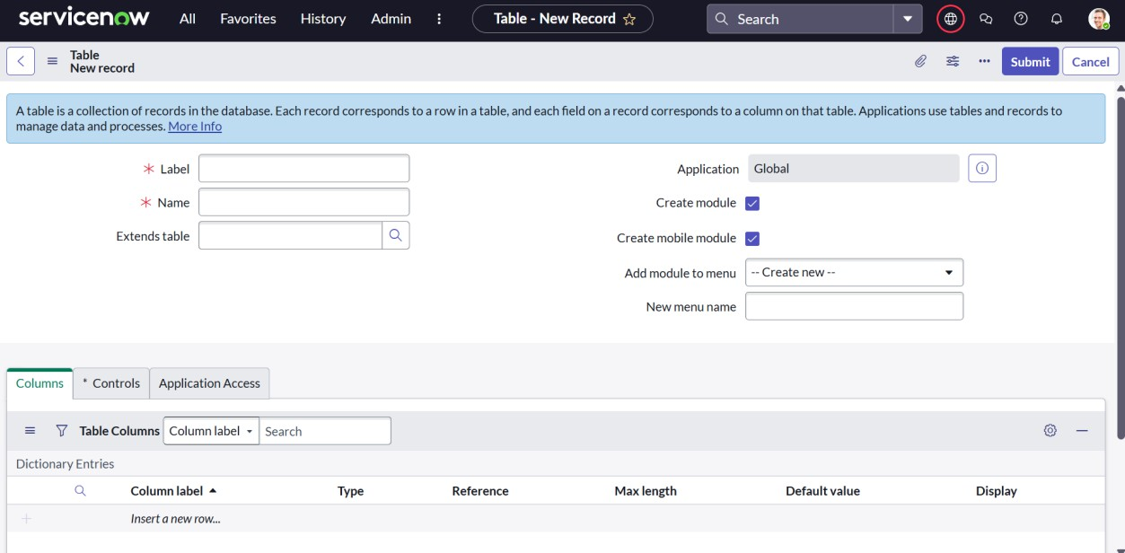
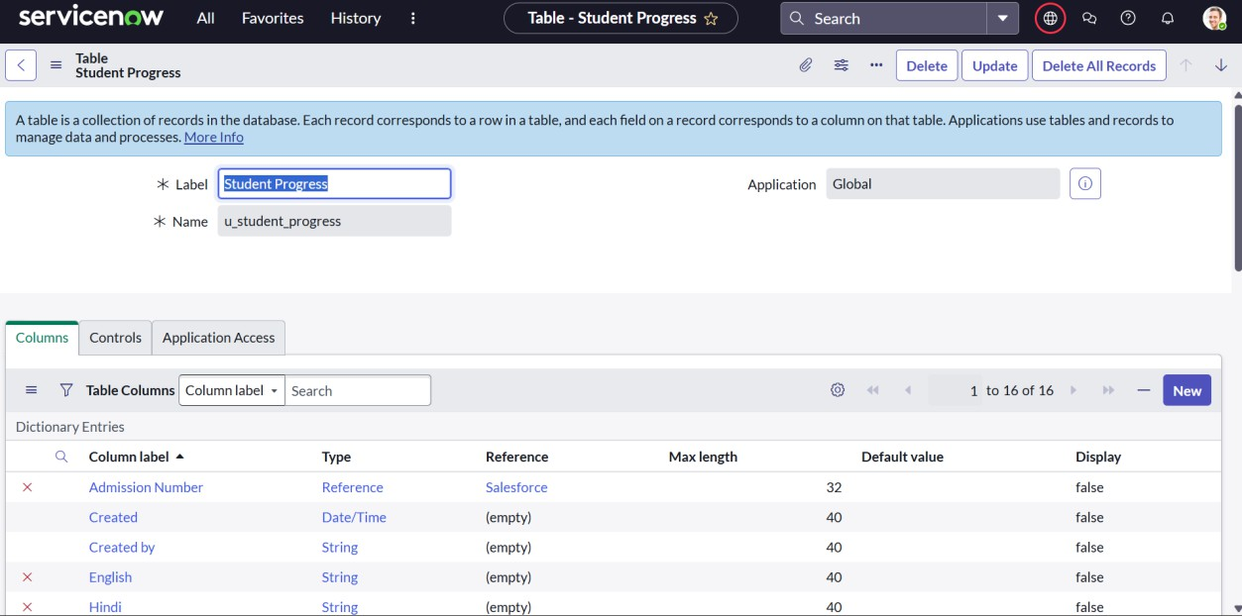

Create Rules for mark
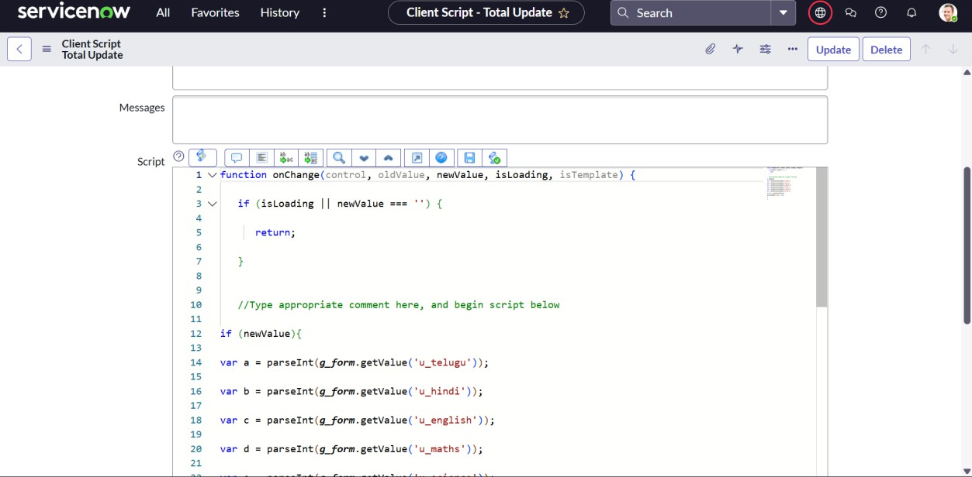

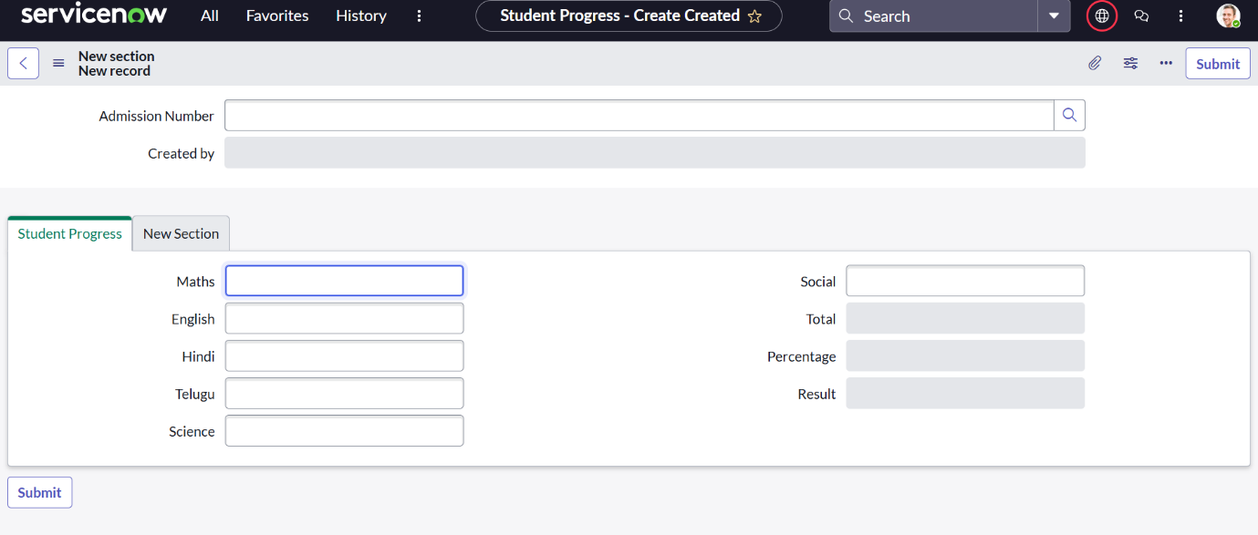
Test Output

